NOTES

What are Semantic Elements?

A semantic element clearly describes its meaning to both the browser and the developer.

Examples of **non-semantic** elements: <div> and <span> - Tells nothing about its content.

Examples of **semantic** elements: <form>, <table>, and <article> - Clearly defines its content.

## The CSS Box Model

In CSS, the term "box model" is used when talking about design and layout.

The CSS box model is essentially a box that wraps around every HTML element. It consists of: content, padding, borders and margins. The image below illustrates the box model:

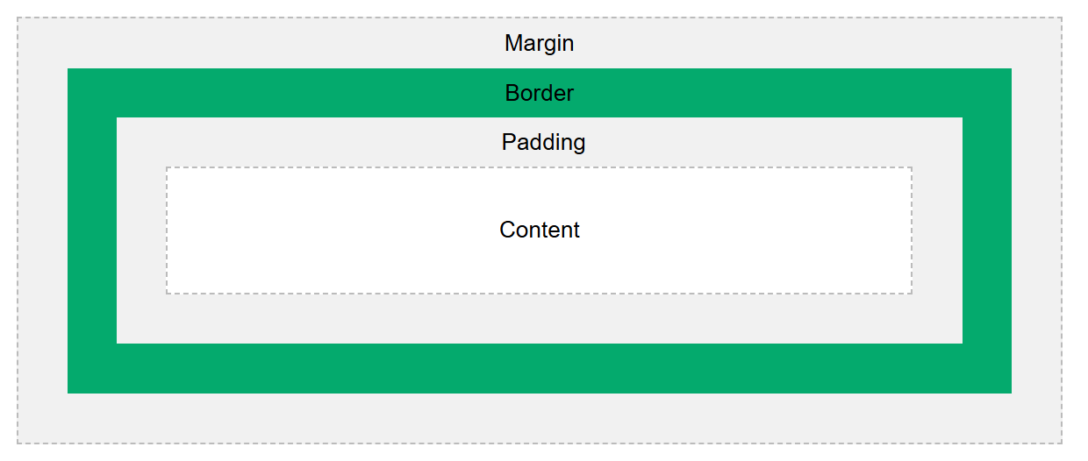

To get no of days from 1970

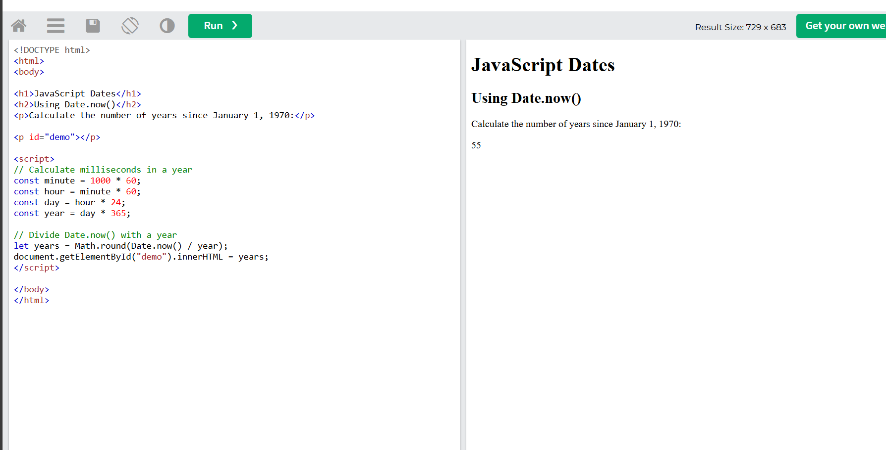

* The DOM defines the logical structure of objects and the way an object is accessed and manipulated.​